Beech Tree Surgery

Patient Survey Report 2011-12

This report shows the practice’s results of the patient survey for 2011-12. The report is based on data collected 18 March – 25 March 2012. Questionnaires could be completed ‘on line’ via the practice website or via hard copy that were available at all sites. All questionnaires completed were anonymous

Prior to the survey being published views were sought from the 19 members of the Patient Reference Group (PRG). Their input was invaluable in determining areas to be covered within the survey & questions to be asked

Data was collected from 294 questionnaires that were returned, this compares favourably with the 249 questionnaires returned in 2010-11 when Ipsos MORI conducted the survey. We are grateful to all those patients who completed the questionnaire

This report shows what patients said, any comments we feel are relevant and where necessary what action we intend to take in response to the replies we received. The Patient Reference Group have been consulted on the results of the survey and asked to highlight any areas from the survey they feel needs particular attention. This report will be made available via the practice website from 30 March 2012 and in paper form at all our 3 sites. Copies will also be sent to North Yorkshire & York NHS & if requested to the Vale of York Commissioning Group. The full survey which includes all patient comments can be found on the homepage of our website; www.beechtreesurgery.co.uk

It is important to note that we, like many businesses are under severe financial pressures. We face ongoing reductions in funding with income reducing year on year and expenditure rising. Our challenge and the challenge for the NHS as a whole is how to maintain services for an ageing population as well as dealing with an ever-increasing demand. In an ideal world where funding was not an issue we would make a number of changes to the services we offer. Sadly we and other NHS bodies increasingly have to make decisions on what is affordable.

Premises
Q1 Which of our 3 sites do you normally use?
Selby 63%
Carlton 12%
Riccall 17%
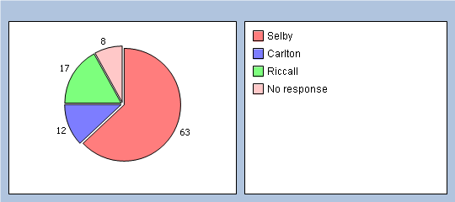

Q2 How easy is it to get to the surgery you normally use?
Very easy 69%
Fairly easy 21%
Not very easy 5%
Not at all easy 0%
Not applicable 0%

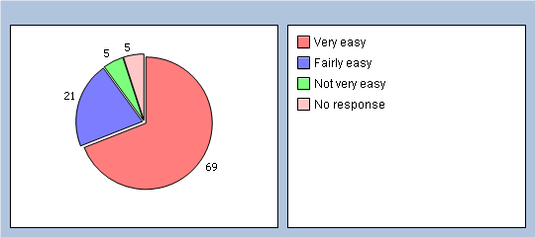

Q3 Is your usual surgery open at times that are convenient to you?
Yes - Go to Q5 78%
No 13%
Don’t know 1%
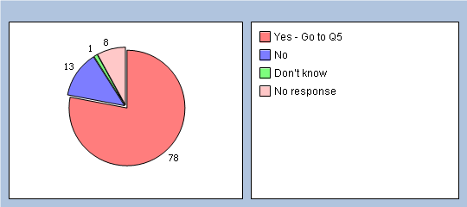

Comment/Action
We operate from 3 sites and currently fulfil an additional service to open longer (Extended Hours). The rules on this are specific, for example the No of hours we have to open are dictated by the No of patients registered with us. These hours MUST be extra and NOT replace existing hours. Our main site is therefore open from 7.00 am to 8.15 pm on Mondays and from 7.00 am to 6.00 pm on Tuesdays.

It is pleasing that the vast majority of respondents were happy with our existing opening hours. Our 2 branch surgeries are only open part time, in an ideal world we would aim to open these longer, however this is not possible given the current financial pressures we face.

Patients who use our branch surgeries of Carlton & Riccall are free to use our main site in Selby when these branches are closed.

Q4 Which of the following additional opening hours would make it easier for you to see or speak to someone? Please tick all boxes that apply.
Before 8am 2%
At lunchtime 1%
After 6.30pm 8%
On a Saturday 7%
On a Sunday 0%
None of these 4%
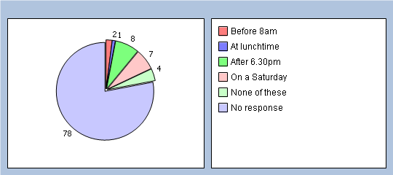

Q5 How clean is the surgery you usually attend?
Very clean 81%
Clean 16%
Not very clean 0%
Dirty 0%
Not applicable 0%
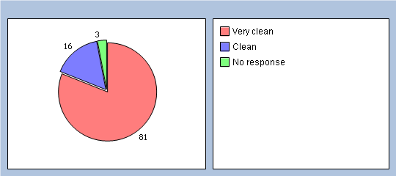

Comment/Action
We are pleased that the vast majority of responses indicated they thought our premise were very clean/clean. We employ 4 cleaners who to avoid disruption work at times when we are closed, either late at night or very early morning. They work to a strict cleaning schedule and adhere to infection control guidelines

Q6 How confident are you that the information we hold about you is confidential?
Very confident 61%
Confident 33%
Not very confident 1%
Not applicable 0%
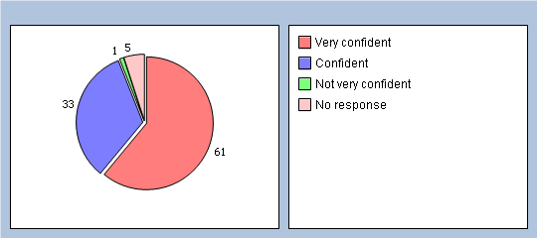

We will
- Update our form of consent to ensure it is more explicit and covers requests made for a third party, e.g. child/dependant

Q7 How confidential do you find the reception areas at the site you usually attend?
Very confidential 24%
Confidential 39%
Not very confidential 33%
Not applicable 0%
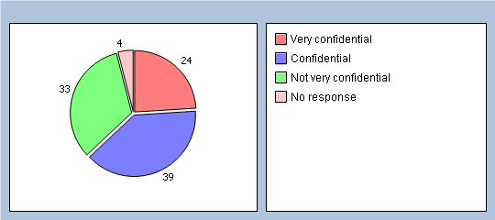

Comment/Action
We are pleased that the vast majority of respondents indicated they felt confident that the information we hold is confidential. We have a duty to comply with all NHS IM&T procedures as well as the Data Protection Act. Dr Merrifield also has specific responsibility for ensuring we adhere to patient confidentiality and acts as the practices Caldicott Guardian

We are aware that there are issues with regards confidentiality in reception areas at all our sites, due to the different layout of these sites there are some things we would like to do but which are not feasible. We are also aware that confidentiality matters relate not just to what may be heard but also what may be seen. In the case of our main surgery the building was designed to be open plan & inviting, this inevitably leads to issues with regards to confidentiality. We have made a number of attempts to improve this but accept that further work is required

We will
- Review working practices at reception at our main site in Selby, including, the need to answer the telephone when on prescriptions, reception window to be closed & only opened when help is required, alter reception windows to improve privacy, examine possibility of barriers in reception to ensure the patient at the desk has more privacy
- Undertake further staff training on confidentiality, specifically relating to common pitfalls.
- Fit strips around doors in our extension to reduce the possibility of conversations being overheard.
- Update our form of consent to ensure it is more explicit

Ordering and Supply of Medication
Q8 How do you normally order your medication?
In person 56%
By fax 0%
On line 14%
Via relative or carer 4%
Via pharmacy 13%
Other 4%
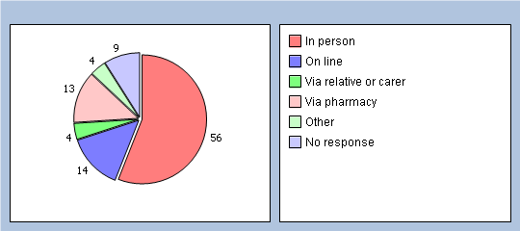

Q9 How easy do you find it ordering a prescription from us?
Very easy 56%
Easy 35%
Difficult 3%
Very difficult 0%
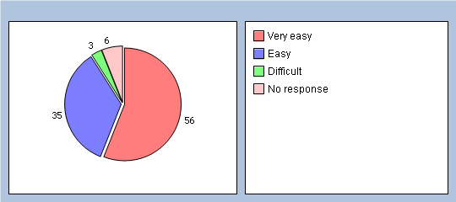

Comment/Action
We are pleased that only a small minority of respondents indicated they found difficult to order a prescription from us.

We will
- Continue to advise patients of the options available to order prescriptions via our website, newsletters etc

Q10 We currently follow PCT guidance and issue medication based on 28 day supply - how happy are you with this system?
Happy 72%
Unhappy 7%
Neither 11%
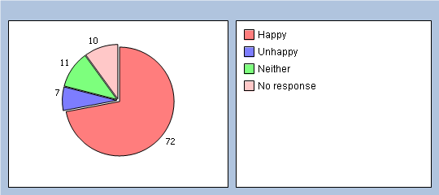

Comment/Action
We are pleased that only a minority of respondents indicated they were unhappy with medications being issued based on a 28-day supply.

We have worked on a 28-day supply for in excess of 10 years, this follows PCT recommendations. Numerous studies have been undertaken which show that the 28-day supply is the optimum amount to reduce waste and therefore make the best use of limited resources. We pay for every item we prescribe and have a budget of £2,000,000+ per annum. We are obliged to live within this budget. We accept that many people may be on medication for long-term conditions and would like a supply of more than 28 days. However, studies have shown that when drugs are returned the majority are for regular, repeat medications such as anti-inflammatory tablets, insulin, inhalers, anti-anginals, anti-hypertensives, anti-depressants and anti ulcer drugs.

Despite this creating more work for us we regret that we are not in a position for change this policy. We do however regularly prescribe 2 x 28 days prescriptions for those that may be going abroad etc. We are aware that there may be some patients who have difficulty in collecting their prescription/medication. The solution to this may be to use the services of a local pharmacy that will order the medication, collect the prescription from us and deliver the medication to the door.

We will
- Increase our efforts in making patients more aware of the services pharmacies offer

About Receptionists and Appointments
Q11 How helpful do you find our receptionists?
Very helpful 65%
Fairly helpful 29%
Not very helpful 1%
Not at all helpful 0%
Don’t know 1%
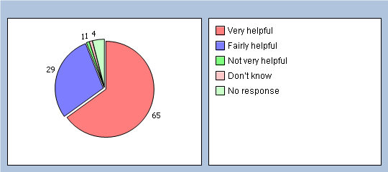

Comment/Action
We are pleased that the majority of respondents indicated they found our receptionist helpful. They are a valuable member of our team and are often the first point of contact for patients. They do a difficult and stressful job and are not there to be obstructive. Their role is to follow the protocols and methods of working as laid down by the Partners and senior management team. They always try to help patients but there may be some things that are outside their control.

Q12 How easy is it to get through to us on the phone?
Very easy 23%
Fairly easy 51%
Not very easy 15%
Not at all easy 2%
Haven’t tried 2%
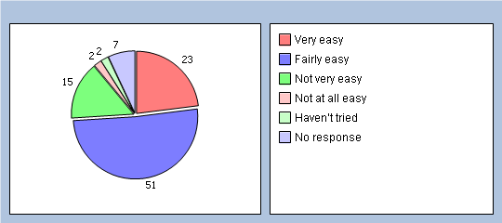

Comment/Action
We receive regular reports from BT detailing the volume of incoming calls, the busiest day of the week, the busiest time of day etc. From this we know our busiest day is Monday and the busiest time of day for incoming calls is 8.00 – 9.30 am. We also know we can realistically only deal with around 7,700 calls per month
We will
- Continue to monitor the number of incoming calls with the aim to ensure we have more staff available for the busy periods
- Encourage patients to try to avoid ringing for results etc during the busy 8.00 – 9.30 time. This is when we receive most calls from patients asking for appointments
- Continue to encourage the use of our internet option for booking appointments, especially for those requiring appointments in specific clinics

Q13 How easy is it to speak to a doctor or nurse on the phone?
Very easy 21%
Fairly easy 42%
Not very easy 8%
Not at all easy 0%
Haven’t tried 22%
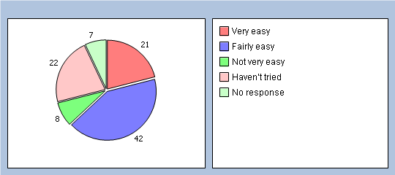

Comment/Action
In addition to seeing a doctor face to face there is also the option for a telephone consultation with a doctor. These can be appropriate in certain circumstances, e.g advice only, certain medication reviews etc. These can be more convenient for the patient and more cost effective for us.

We will
- Continue to offer telephone consultations as an alternative to face to face where it is appropriate
- Monitor the proportion of face to face v telephone consultations in an effort to ensure the most cost effective yet safe method of working

Q14 If you need to see a GP urgently, can you normally get seen on the same day?
Yes 50%
No 18%
Don’t know/never needed to 26%
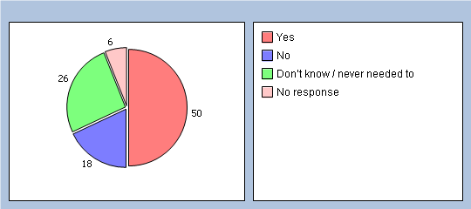

Comment/Action
If patients require a same day appointment for a medical problem that will not wait until the next routine appointment the receptionists have only a limited number of options available to them. These being either an appointment in the same day clinic (this tends to be minor Illness only), an urgent appointment that day with a GP (this tends to be branch sites only), a time when a GP will call the patient to assess the condition and take the appropriate action.

We are increasingly working with reduced funding with demands on our services increasing; we therefore have to make best use of all available resources

We will
- Aim to increase awareness of other options available to patients both internally e.g. health professionals other than a doctor and externally eg NHS Direct, local pharmacies
- Encourage patients to ring for a same day appointment ONLY if their appointment is medically urgent.
- Set up an alert facility via text messages to remind patients of their appointment

Q15 How important is it to you to be able to book appointments ahead of time?
Important 84%
Not important 9%
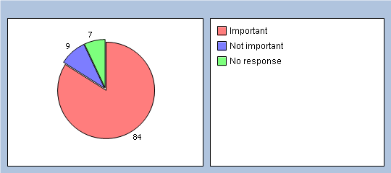

Comment/Action
From audits we have carried out there is a direct link between booking appointments ahead and the number of patients who ‘Do Not Attend’ (DNA). The further in advance patients book the greater the chance of them DNA’ing. We average 115 DNA’s per month; this is a loss of 28 hours of doctor/nurse time. In an effort to ease this situation we have looked at setting a limit that appointments for a GP/Nurse cannot be booked more than 2 weeks in advance.

We will
- Due to the importance place on being able to book appointments in advance we will NOT set a 2 week limit but will continue to monitor until the end of the year
- Write to patients who DNA 3 times in any 12-month period advising that should the situation persist we will ask they be removed from our practice list.

Q16 How easy is it to for you to book appointments ahead?
Very easy 29%
Fairly easy 48%
Not very easy 12%
Not at all easy 1%
Haven’t tried 4%
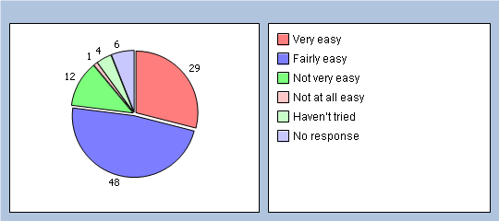

Q17 How do you normally book your appointment? Please tick all boxes that apply.
In person 9%
By phone 64%
On line 7%

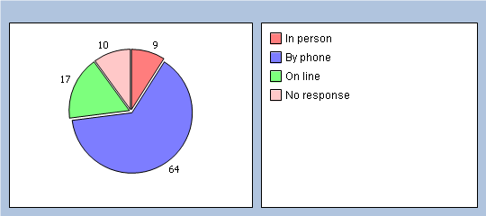
Q18 Which of the following methods would you prefer to use to book appointments? Please tick all boxes that apply.
In person 11%
By phone 59%
On line 22%

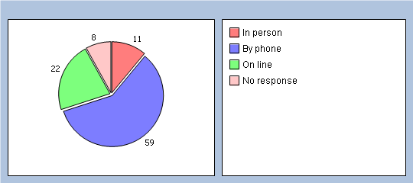

Comment/Action
There are benefits of using our ‘on line’ systems. It can be more convenient for patients allowing them to see the full range of appointments available and ease the demand on our telephone system. From the figures above it would appear than some patients may not be aware of the ‘on line’ facility.

We will
- Continue to promote the use of ‘on line’ services via website, newsletters and if possible on prescription counterfoils

Thinking of times when you want to see a particular doctor:
Q19 How quickly do you usually get seen?
Same day or next day 10%
2-4 days 44%
5 days or more 32%
not applicable 9%
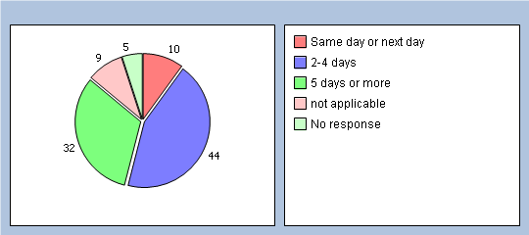

Q20 How do you rate this?
Excellent 10%
Very good 23%
Good 22%
Fair 23%
Poor 8%
Very poor 1%
Does not apply 5%

Comment/Action
We always encounter difficulties when patients wish to see specific GPs. This is largely due to the fact that including Selby Hospital we work over 4 sites. As a result, even when all GP’s are present getting to see a GP of a patient’s choice may not be easy and cannot necessarily be accommodated in the short term. This problem is compounded when a doctor is on holiday.

We will
- Aim to minimise the problem by reviewing the times when doctors are absent
- Review the impact of reducing the number of doctors who work at each site. Currently 6 doctors work at Carlton & Riccall. This may improve then problem at Selby but make matters worse at both Carlton & Riccall

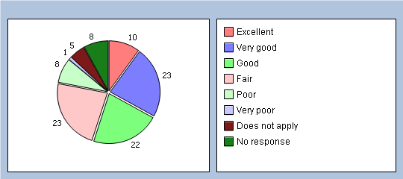

Thinking of times when you are willing to see any doctor:
Q21 How quickly do you usually get seen?
Same day or next day 43%
2-4 days 34%
5 days or more 6%
I don’t usually need to be seen quickly 2%
Don’t know, never tried 9%
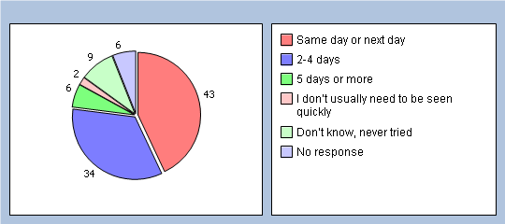

Q22 How do you rate this?
Excellent 22%
Very good 27%
Good 22%
Fair 10%
Poor 4%
Very poor 0%
Does not apply 9%
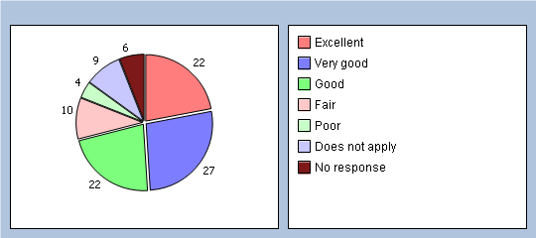

Consultations with a Doctor

Thinking of your most recent face to face consultation with a doctor
Q23 How long did you wait for your consultation to start?
Less than 5 minutes 31%
5 – 10 minutes 44%
11 – 20 minutes 14%
21 – 30 minutes 4%
More than 30 minutes 1%
There was no set time for my consultation 1%
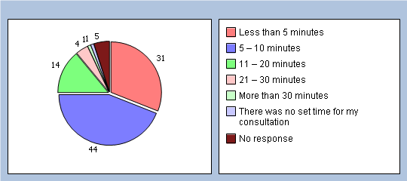

Q24 How do you rate this?
Excellent 33%
Very good 27%
Good 18%
Fair 10%
Poor 3%
Very poor 0%
Does not apply 2%

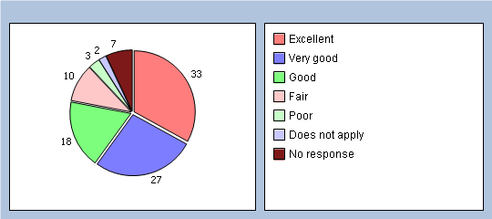

Comment/Action
National research now shows that the average length of a consultation is 12½ minutes.
At our branch sites we work on 10-minute appointments, as a result it is very difficult for a clinician to see patients at the time of their appointment hence the waiting times indicated above. Within the last few months’ appointment times at Selby have changed from 10 minute to 15-minute intervals.

Closer analysis of the results indicate that patients wait longer at branch surgeries where 10 minute appointments are the norm than they do at Selby where 15 minute appointments are standard.

We will
- Review the length of appointments at branch surgeries to identify the implications of moving to 12-15 minute appointments

Thinking of your most recent telephone consultation with a doctor
Q25 How do you rate this?
Excellent 25%
Very good 23%
Good 12%
Fair 1%
Poor 1%
Very poor 0%
Does not apply 31%
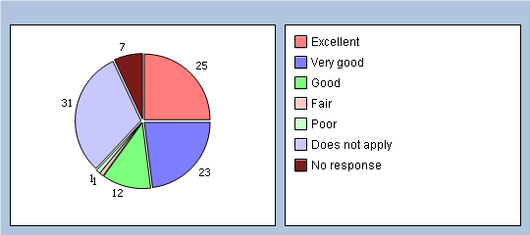

How good was the last doctor you saw at each of the following?

(If you haven’t seen a GP in your practice in the last 6 months, please go to Q32)
Q26 Giving you enough time
Very good 72%
Good 15%
Fair 1%
Poor 0%
Very poor 0%
Does not apply 0%
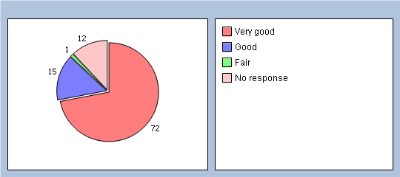

Q27 Listening to you
Very good 76%
Good 13%
Fair 0%
Poor 0%
Very poor 0%
Does not apply 0%
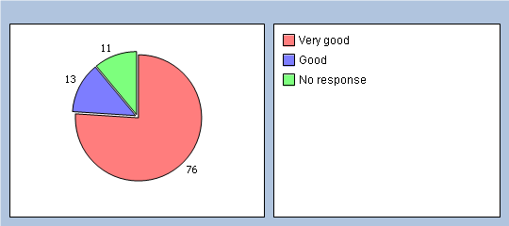

Q28 Explaining tests and treatments
Very good 70%
Good 19%
Fair 0%
Poor 0%
Very poor 0%
Does not apply 1%
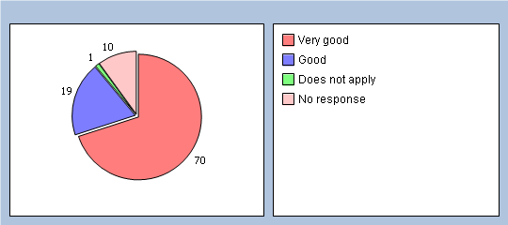

Q29 Involving you in decisions about your care
Very good 64%
Good 18%
Fair 1%
Poor 0%
Very poor 0%
Does not apply 4%
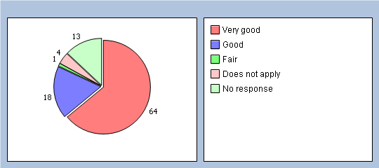

Q30 Treating you with care and concern
Very good 69%
Good 17%
Fair 1%
Poor 0%
Very poor 0%
Does not apply 0%
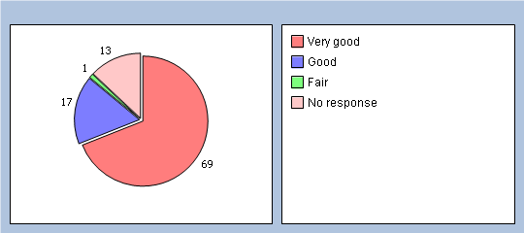

Q31 Did you have confidence and trust in the GP you saw or spoke to?
Yes, definitely 86%
Yes, to some extent 5%
No, not at all 0%
Don’t know / can’t say 0%
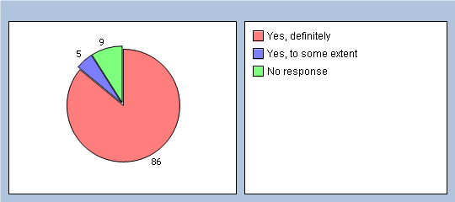

Comment/Action
We are pleased with the results of Q25-31. It largely supports our view that the to 15 minute appointments gives a better experience for the patient and allows more time for doctor to discuss matters with the patient.

Consultations with a Nurse

How good was the last nurse you saw at each of the following?
(If you haven’t seen a nurse in your practice in the last 6 months, please go to Q43)
Q32 Giving you enough time
Very good 52%
Good 19%
Fair 2%
Poor 0%
Very poor 0%
Does not apply 2%
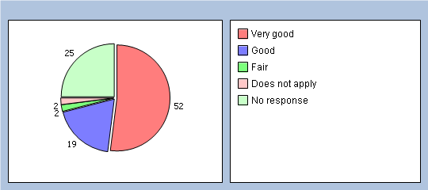

Q33 Listening to you
Very good 52%
Good 20%
Fair 2%
Poor 0%
Very poor 0%
Does not apply 2%
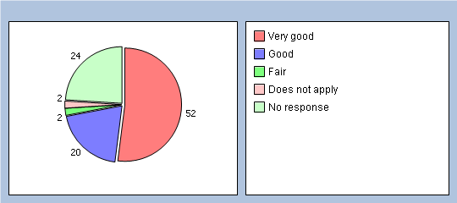

Q34 Explaining tests and treatments
Very good 46%
Good 22%
Fair 3%
Poor 0%
Very poor 0%
Does not apply 4%
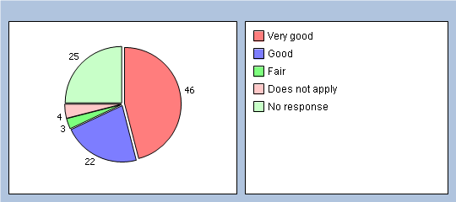

Q35 Involving you in decisions about your care
Very good 44%
Good 20%
Fair 3%
Poor 0%
Very poor 0%
Does not apply 8%
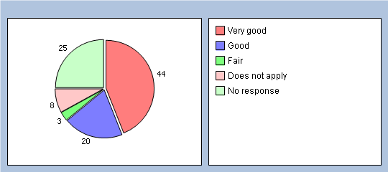

Q36 Treating you with care and concern
Very good 52%
Good 17%
Fair 3%
Poor 1%
Very poor 0%
Does not apply 3%
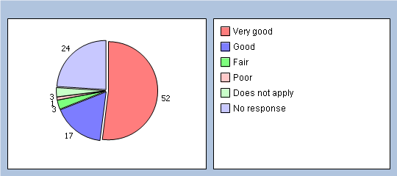

Q37 Did you have confidence and trust in the nurse you saw or spoke to?
Yes, definitely 62%
Yes, to some extent 11%
No, not at all 0%
Don’t know / can’t say 2%
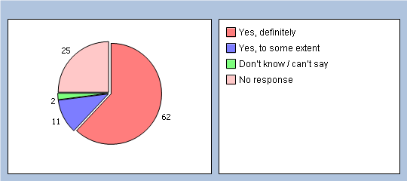
If you know the name of the nurse you last saw, please write it here:

Comment/Action
The nursing team provide a wide range of services including carrying out simple diagnostic tests, treatment room work, family planning, dedicated clinics for long term conditions and same day minor illness clinics. The length of appointments varies depending on the nature of the clinic/service provided and this tends to be reflected in the responses. Individual nurses have specific skills and have undergone enhanced training in certain conditions.

We will
- Discuss the findings of these specific replies with the nursing team
- Aim to ensure patients are booked in with the most appropriate clinician/clinic in order to ensure they gain maximum benefit

About Care Received from Doctors and Nurses

Thinking about the care you get from your doctors and nurses overall, how well does the practice help you to:
Q38 Understand your health problems?
Very well 84%
Unsure 5%
Not very well 0%
Does not apply 1%
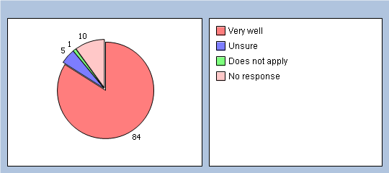

Q39 Cope with your health problems
Very well 81%
Unsure 8%
Not very well 0%
Does not apply 2%
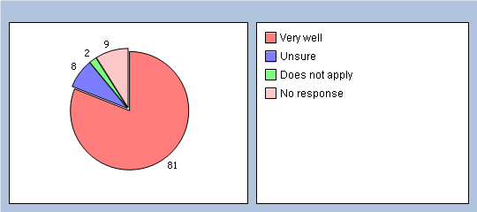

Q40 Keep yourself healthy
Very well 73%
Unsure 12%
Not very well 0%
Does not apply 4%
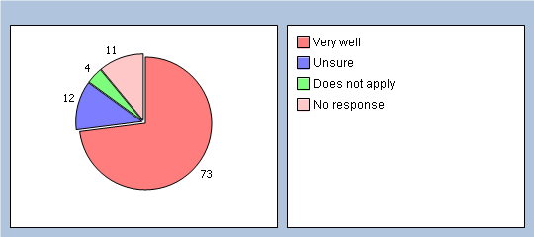

Q41 Overall, how would you describe your experience of your GP surgery?
Excellent 47%
Very good 35%
Good 6%
Fair 1%
Poor 0%
Very poor 0%
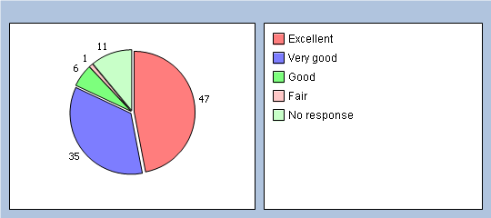

Q42 Would you recommend your GP surgery to someone who has just moved to your local area?
Yes, definitely 79%
Yes, probably 9%
No, probably not 2%
No, definitely not 0%
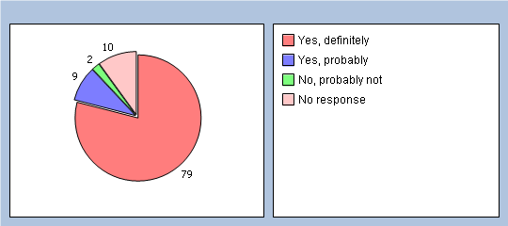

Thinking of Email Communication
Q43 If it was possible to implement, how useful would you find email communication with a doctor?
Very useful 28%
Fairly useful 19%
Not very useful 30%
Unsure 17%
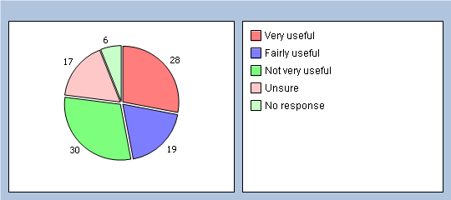

Comment/Action
In recent years we have developed and increased the use of telephone consultations, the next step may be the use of email communication with a doctor.

We will
- Explore the possibilities of piloting this for a short period of time before assessing its usefulness and its limitations

About You

It will help us to understand your answers if you could tell us a little about yourself
Q44 Are you?
Male 41%
Female 49%
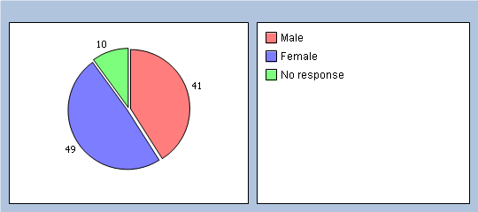

Q45 How old are you?
Under 16 1%
16 to 44 27%
45 to 64 31%
65 to 74 24%
75 or over 12%
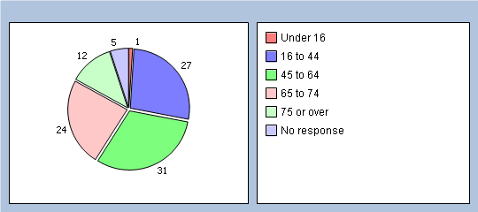

Q46 Do you have a long-standing health condition?
Yes 54%
No 33%
Don’t know/can’t say 1%
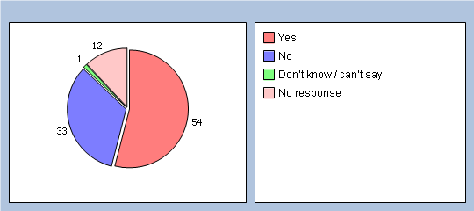

Q47 What is your ethnic group?
White 86%
Black or Black British 2%
Asian or Asian British 0%
Mixed 0%
Chinese 0%
Other ethnic group 3%
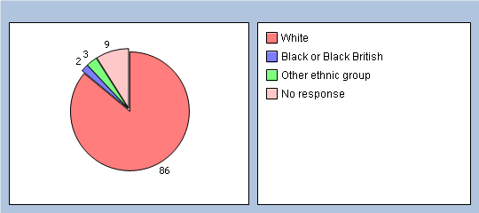

Q48 Which of the following best describes you?
Employed (full or part time, including self-employed) 42%
Unemployed / looking for work 2%
At school or in full time education 3%
Unable to work due to long-term sickness 4%
Looking after your home/family 5%
Retired from paid work 40%
Other 1%


